CS 499 Module One Assignment Template

Complete this template by replacing the bracketed text with the relevant information.

- Self-Introduction: Address all of the following questions to introduce yourself.

  - How long have you been in the Computer Science program?
I’ve been enrolled in SNHU and the CS program since January of 2024. So, I’ve been in this program for a little over two years.

  - What have you learned while in the program? List three of the most important concepts or skills you have learned.
I’ve learned an extensive list of skills; however, I would say the three most important concepts/skills I’ve learned and developed are my curiosity, my ability to overcome obstacles, and my increased confidence in problem solving. These are powerful traits that are welcomed in any computer scientist, and I believe these qualities will separate me from my peers moving forward.

  - Discuss the specific skills you aim to demonstrate through your enhancements to reach each of the course outcomes.
I plan to demonstrate my skills regarding secure coding (ensuring CIA of data and mitigating vulnerabilities), embedded systems development (interacting with a physical environment and leveraging databases and visualization techniques for user comprehension), and AI concepts/principles (becoming confident in creating and training reinforcement learning algorithms).

  - How do the specific skills you will demonstrate align with your career plans related to your degree?
I have yet to decide on a specific path for my professional career, however, I’m extremely interested in cybersecurity, AI, and embedded systems. Hence, my artifact and enhancements decisions.

  - How does this contribute to the specialization you are targeting for your career?
These enhancements provide a direct demonstration of my abilities to create systems and code that satisfy requirements while also highlighting my ability to push myself professionally and personally.

- ePortfolio Set Up:

  - Submit a screen capture of your ePortfolio GitHub Pages home page that clearly shows your URL.
    - You already have a repository in GitHub where you uploaded projects in previous courses. Your ePortfolio will reside in GitHub but can link to work at other sites, such as Bitbucket.

  - Use the GitHub Pages link in the Resource section for directions on:
    - How to create your GitHub website and publish code to GitHub Pages
    - Issues, such as adding links to other sites

  - Paste a screenshot of your GitHub Pages home page with your URL clearly showing in the space below.

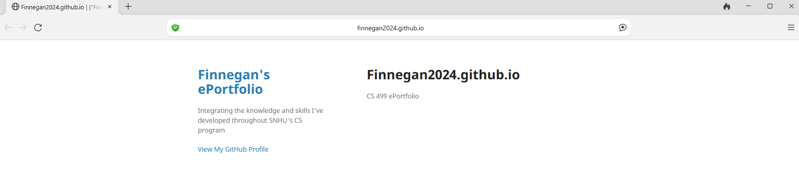

- Enhancement Plan:

  - Category One: Software Engineering and Design
    - Select an artifact that is aligned with the software engineering and design category and explain its origin. Submit a file containing the code for the artifact you choose with your enhancement plan.

I plan on using a thermostat.py file artifact which leverages a raspberry pi 4 with a temperature & humidity sensor, leds, and buttons to relay state information via an LCD screen while also sending the state information (serially) to a server (a secondary script). This artifact originates from the CS 350 class.

Note: Your artifact may be work from the following courses:

- IT 145: Foundation in Application Development
- CS 250: Software Development Lifecycle
- CS 260: Data Structures and Algorithms
- IT 315: Object Oriented Analysis and Design
- CS 320: Software Testing, Automation, and Quality Assurance
- CS 330: Computational Graphics and Visualization
- CS 340: Advanced Programming Concepts
- CS 350: Emerging Systems Architectures and Technologies
- CS 360: Mobile Architecture and Programming
- IT 365: Operating Environments
- IT 380: Cybersecurity and Information Assurance
- CS 405: Secure Coding
- CS 410: Reverse Software engineering
- IT 340: Network and Telecommunication Management
- IT 380: Cybersecurity and Information Assurance

    - Describe a practical, well-illustrated plan for enhancement in alignment with the category, including a pseudocode or flowchart that illustrates the planned enhancement.

I plan on creating a secure device-to-server pipeline that implements device identification, secure transportation, authentication, replay protection, and secure storage of data. This plan incorporates separation of concerns, reliability, security, and maintainability as software engineering & design enhancements.

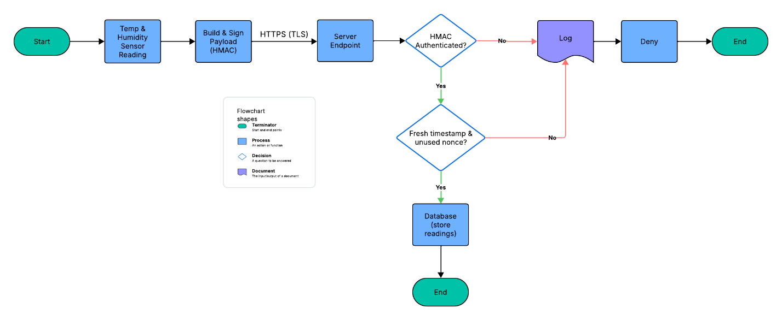

For this category of enhancement, consider improving a piece of software, transferring a project into a different language, reverse engineering a piece of software for a different operating system, or expanding a project’s complexity. These are just recommendations. Consider being creative and proposing an alternative enhancement to your instructor.

Think about what additions to include to complete the enhancement criteria in this category. Since one example option is to port to a new language, that is the kind of scale that is expected. This does not mean you need to port to a new language but instead have an equivalent scale of enhancement. Underlying expectations of any enhancement include fixing errors, debugging, and cleaning up comments, but these are not enhancements themselves.

    - Explain how the planned enhancement will demonstrate specific skills and align with course outcomes.

      - Identify and describe the specific skills you will demonstrate that align with the course outcome.

This enhancement focuses on improving the quality of an existing code base, addressing limitations, and mitigating vulnerabilities to highlight my knowledge within embedded systems and cybersecurity.

      - Select one or more of the course outcomes below that your enhancement will align with.

This enhancement aligns with “Design, develop, and deliver professional-quality oral, written, and visual communications that are coherent, technically sound, and appropriately adapted to specific audiences and contexts” via documentation and diagrams to ensure all stakeholders understand the system. It also aligns with “Design and evaluate computing solutions that solve a given problem using algorithmic principles and computer science practices and standards appropriate to its solution, while managing the trade-offs involved in design choices” as I’ll be opting for HMAC-signed payloads instead of device certificates. This demonstrates my ability to assess tradeoffs such as ease of implementation vs very strong security for embedded systems. Another outcome this enhancement aligns with is “Demonstrate an ability to use well-founded and innovative techniques, skills, and tools in computing practices for the purpose of implementing computer solutions that deliver value and accomplish industry-specific goals” as this enhancement is focused on leveraging HMAC-signed payloads, replay protection, TLS, and secret handling. Lastly, this enhancement aligns with “Develop a security mindset that anticipates adversarial exploits in software architecture and designs to expose potential vulnerabilities, mitigate design flaws, and ensure privacy and enhanced security of data and resources” as I’ll be focusing on strong security measures and real-world threats.

Course Outcomes:

- Employ strategies for building collaborative environments that enable diverse audiences to support organizational decision-making in the field of computer science.
- Design, develop, and deliver professional-quality oral, written, and visual communications that are coherent, technically sound, and appropriately adapted to specific audiences and contexts.
- Design and evaluate computing solutions that solve a given problem using algorithmic principles and computer science practices and standards appropriate to its solution while managing the trade-offs involved in design choices.
- Demonstrate an ability to use well-founded and innovative techniques, skills, and tools in computing practices for the purpose of implementing computer solutions that deliver value and accomplish industry-specific goals.
- Develop a security mindset that anticipates adversarial exploits in software architecture and designs to expose potential vulnerabilities, mitigate design flaws, and ensure privacy and enhanced security of data and resources.

  - Category Two: Algorithms and Data Structures

- Select an artifact that is aligned with the algorithms and data structures category and explain its origin. Submit a file containing the code for the artifact you choose with your enhancement plan. You may choose work from the courses listed under Category One.

I plan on using a DQN .ipynb file artifact which leverages a neural network with 2 hidden layers to control an NPC. The goal of the assignment was to develop my own Q-training algorithm to find the best possible navigation sequence while maximizing reward to achieve a 100%-win rate. This artifact originates from the CS 370 class.

- Describe a practical, well-illustrated plan for enhancement in alignment with the category, including a pseudocode or flowchart that illustrates the planned enhancement.

I plan on enhancing my DQN using a prioritized experience replay implemented with a SumTree. The binary SumTree is a core data structure, and this enhancement will also demonstrate time complexity optimization by changing the replay buffer from a uniform O(N) to a prioritized replay buffer O(log N). This improves sampling speed and can be verified using benchmarks such as sampling time per batch, updates/sec, and steps/sec.

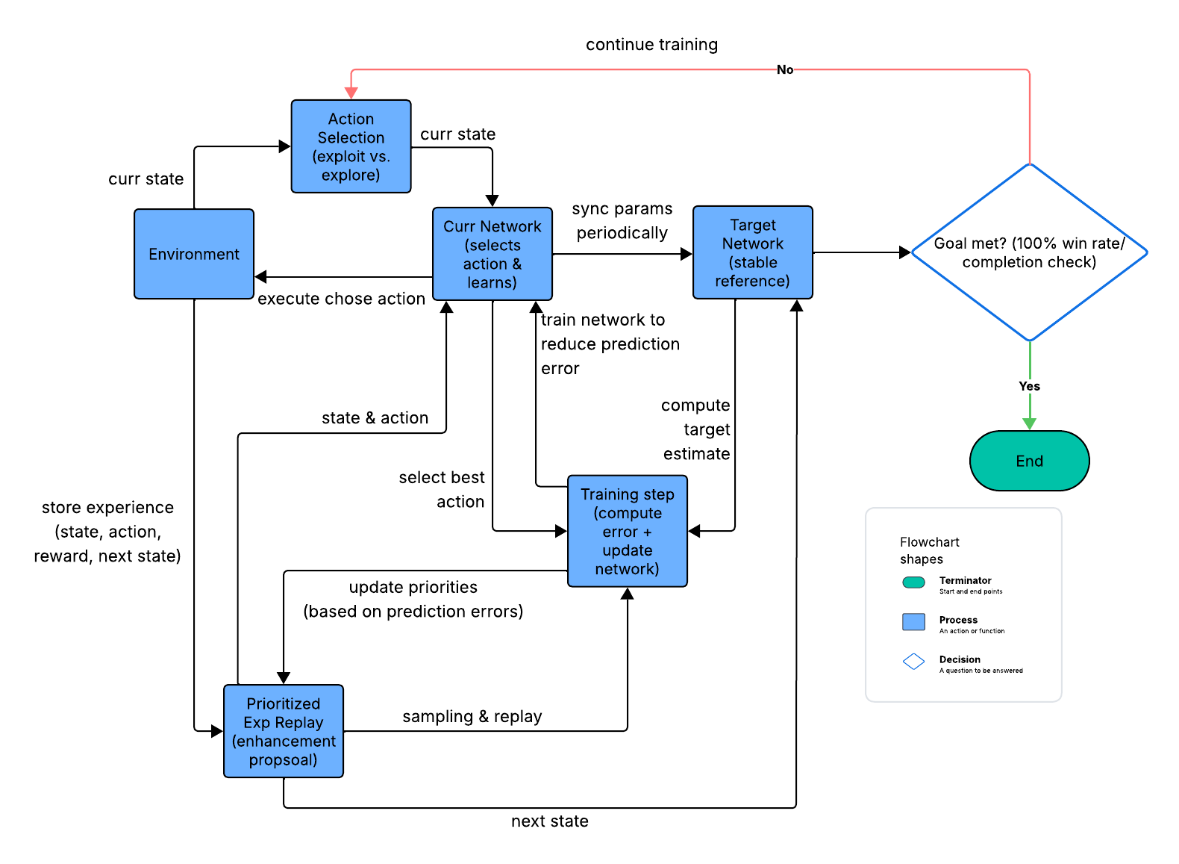

For this category of enhancement, consider improving the efficiency of a project or expanding the complexity of the use of data structures and algorithms for your artifact. These are just recommendations. Consider being creative and proposing an alternative enhancement to your instructor. Note: You only need to choose one type of enhancement per category.

Think about what additions to include to complete the enhancement criteria in this category. Since one example option is to port to a new language, that is the kind of scale that is expected. Perhaps you might increase the efficiency and time complexity of an algorithm in an application and detail the logic of the increased time complexity. Remember, you do not need to port to a new language but instead have an equivalent scale of enhancement. Underlying expectations of any enhancement include fixing errors, debugging, and cleaning up comments, but these are not enhancements themselves.

- Explain how the planned enhancement will demonstrate specific skills and align with course outcomes.

  - Identify and describe the specific skills you will demonstrate to align with the course outcome.

This enhancement focuses on optimization, time complexity, and throughput to highlight my knowledge within reinforcement learning algorithms.

  - Select one or more of the course outcomes listed under Category One that your enhancement will align with.

This enhancement aligns with “Design, develop, and deliver professional-quality oral, written, and visual communications that are coherent, technically sound, and appropriately adapted to specific audiences and contexts” via documentation and diagrams to ensure all stakeholders understand the system. It also aligns with “Design and evaluate computing solutions that solve a given problem using algorithmic principles and computer science practices and standards appropriate to its solution, while managing the trade-offs involved in design choices” as I’ll be opting for a prioritized experience replay instead of a uniform replay buffer. This demonstrates my ability to assess tradeoffs such as ease of implementation vs faster sampling and lower memory overhead. Another outcome this enhancement aligns with is “Demonstrate an ability to use well-founded and innovative techniques, skills, and tools in computing practices for the purpose of implementing computer solutions that deliver value and accomplish industry-specific goals” as this enhancement is focused on leveraging data structures with verifiable time complexity improvements.

  - Category Three: Databases

    - Select an artifact that is aligned with the databases category and explain its origin. Submit a file containing the code for the artifact you choose with your enhancement plan. You may choose work from the courses listed under Category One.

I plan on using a thermostat.py file artifact which leverages a raspberry pi 4 with a temperature & humidity sensor, leds, and buttons to relay state information via an LCD screen while also sending the state information (serially) to a server (a secondary script). This artifact originates from the CS 350 class.

    - Describe a practical, well-illustrated plan for enhancement in alignment with the category, including a pseudocode or flowchart that illustrates the planned enhancement.

I plan on creating a secure device-to-server pipeline that implements device identification, secure transportation, authentication, replay protection, and secure storage of data. This plan incorporates schema designs, meaningful queries, constraints, and mitigations as database enhancements.

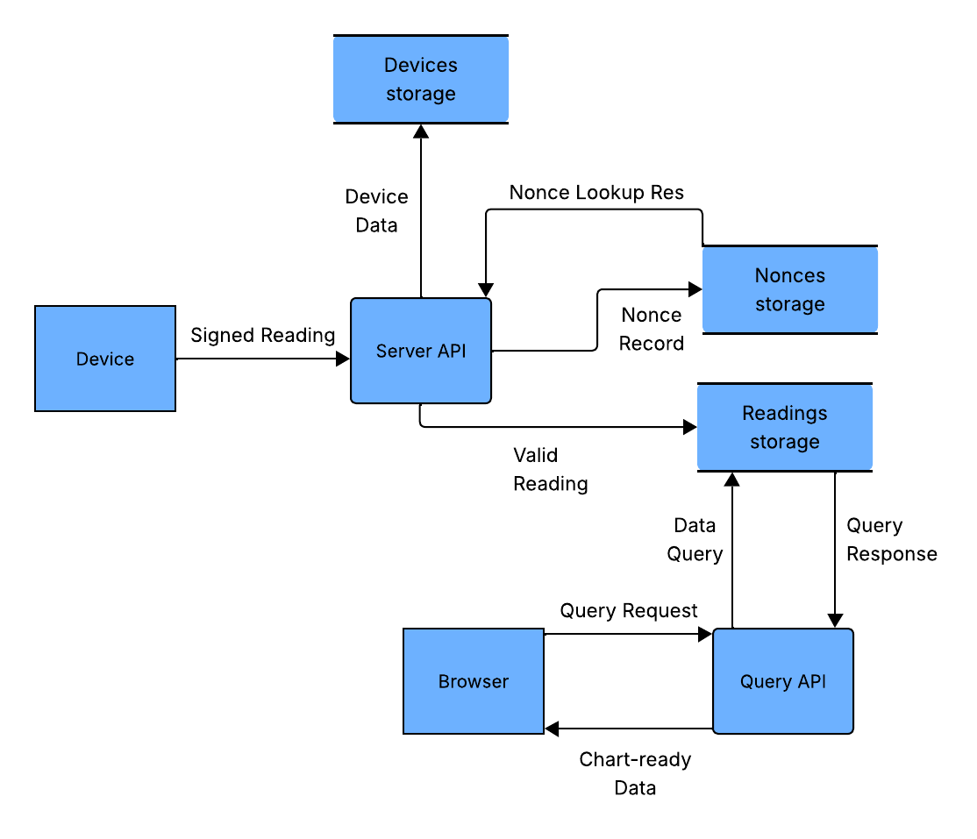

For this category of enhancement, consider adding more advanced concepts of MySQL, incorporating data mining, creating a MongoDB interface with HTML/JavaScript, or building a full stack with a different programming language for your artifact. These are just recommendations; consider being creative and proposing an alternative enhancement to your instructor. Note: You only need to choose one type of enhancement per category.

Think about what additions to include to complete the enhancement criteria in this category. Since one example option is to port to a new language, that is the kind of scale that is expected. Perhaps you might increase the efficiency and time complexity of an algorithm in an application and detail the logic of the increased time complexity. Remember, you do not need to port to a new language but instead have an equivalent scale of enhancement. Underlying expectations of any enhancement include fixing errors, debugging, and cleaning up comments, but these are not enhancements themselves.
    - Explain how the planned enhancement will demonstrate specific skills and align with course outcomes.

      - Identify and describe the specific skills you will demonstrate that align with the course outcome.

This enhancement focuses on improving the quality of an existing code base, addressing limitations, and mitigating vulnerabilities to highlight my knowledge within embedded systems and cybersecurity.

      - Select one or more of the course outcomes listed under Category One that your enhancement will align with.

This enhancement aligns with “Design, develop, and deliver professional-quality oral, written, and visual communications that are coherent, technically sound, and appropriately adapted to specific audiences and contexts” via documentation and diagrams to ensure all stakeholders understand the system. It also aligns with “Design and evaluate computing solutions that solve a given problem using algorithmic principles and computer science practices and standards appropriate to its solution, while managing the trade-offs involved in design choices” as I’ll be opting for a HMAC-signed payloads instead of device certificates. This demonstrates my ability to assess tradeoffs such as ease of implementation vs very strong security for embedded systems. Another outcome this enhancement aligns to is “Demonstrate an ability to use well-founded and innovative techniques, skills, and tools in computing practices for the purpose of implementing computer solutions that deliver value and accomplish industry-specific goals” as this enhancement is focused leveraging HMAC-signed payloads, replay protection, TLS, and secret handling. Lastly, this enhancement aligns with “Develop a security mindset that anticipates adversarial exploits in software architecture and designs to expose potential vulnerabilities, mitigate design flaws, and ensure privacy and enhanced security of data and resources” as I’ll be focusing on strong security measures and real-world threats.

- ePortfolio Overall Skill Set

  - Accurately describe the skill set to be illustrated by the ePortfolio overall.
    - Skills and outcomes planned to be illustrated in the code review

The code reviews are expected to highlight my ability to improve code quality, reduce bottlenecks, catch errors, and promote adherence to best practices and principles. This aligns to multiple course outcomes such as designing solutions derived from best practices and principles, and demonstrating my ability to leverage techniques and tools to deliver value and accomplish goals.

    - Skills and outcomes planned to be illustrated in the narratives

The narratives are expected to demonstrate my ability to communicate intent efficiently, deliver outcomes and results to various audiences, and promote technically sound guidance. This will facilitate my shift from a student perspective to a professional perspective. This aligns with multiple course outcomes such as ensuring communication is adapted for multiple audiences and contexts, and ensuring all stakeholders are able to assist in organization decision making.

    - Skills and outcomes planned to be illustrated in the professional self-assessment

The self-assessments are expected to develop my self-awareness, critical thinking, and accountability while improving my communication skills, problem solving, and goal-setting abilities. This also aligns with the course outcomes that the narratives address.

